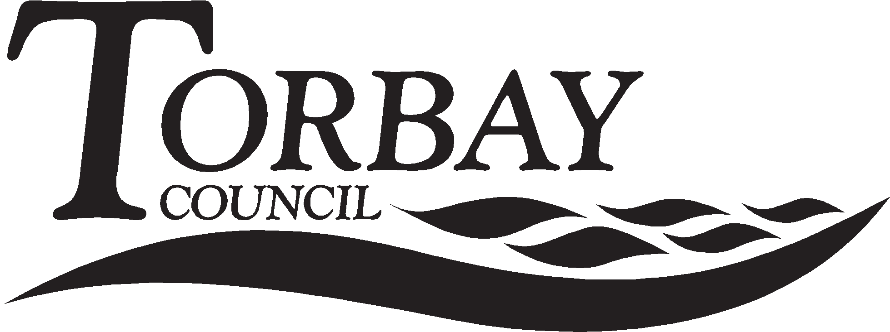
Application for Free School Meals

Your name and address:

Mr/Mrs/Miss/Ms Initial(s).............. Surname ..................................................................................................

Address ..............................................................................................................................................................

...........................................................................................................................................................................

Post Code: ....................................... Telephone ..................................................................................................

Email .............................................................. Relationship to Child(ren)..........................................................

Details about you and your partner (those living at the same address)

Mr/Mrs/ Miss/Ms | Full Legal name | Date of Birth | National Insurance Number

- Details about the children for whom you receive Child Benefit that attend a school in Torbay

Forename(s) | M/ F | Surname | Date of Birth | Name of School Attended | New School? Yes/No | If Yes - start date

- Which benefit do you receive? (Please tick all boxes that apply)

Income support |  | Child tax credit(without working tax credit) and an annual income below £16,190
Income based job seekers allowance |  | Employment and support allowance (income related)
Working Tax credit run on only |  | Universal Credit
Guaranteed element of pension credit |  | Support under part VI of the Immigration and Asylum Act 1999

5. Universal Credit
If you are in receipt of Universal Credit, is your net earned family income over £7,400 per year? (Please place an X in the appropriate box).
Your net earned income is your household income after taxes and deductions. It does not include income through Universal Credit or other benefits that you may receive.

Yes No Unsure

Please note: Contributions Based Jobseeker’s Allowance and Working Tax Credit do not qualify.

I wish Torbay Council to be able to assess my claim in future via a secure computer link with the Department for Education. I agree that Torbay Council can use the information I have provided to process my claim for free school meals and can contact other sources as allowed by law to verify my initial and continuing entitlement.

6. Declaration: I confirm that I have parental responsibility for or care of the child(ren) named on this form. As far as I know the information I have given above is correct. I will tell you immediately if my details above or circumstances change.

Your signature.......................................................................... Date...................................................................

Please return to: Student Services, Electric House, Room SF338, c/o Town Hall, Torquay TQ1 3DR or your child’s school.
Important

Any child with an existing claim for free school meals on 1st April 2018 or gaining eligibility after 1st April 2018 will be protected against losing free school meals during the Universal Credit roll out period. This is expected to complete in March 2022. Once the Universal Credit is fully rolled out, the information provided on this form will be used to check ongoing entitlement for children still of school age. Any existing claimants who no longer meet the eligibility criteria will continue to receive free school meals until the end of their current phase of education (i.e. primary or secondary). If you have children who have an existing free school meals claim and are therefore protected, if you are now applying for another child and are not eligible, they will not be awarded free school meals as well. The protection applies to individual children, not families. In order to perform checks we need up to date details. It is therefore essential for you to let us know of any changes of details of the person receiving the qualifying benefit.

How do I qualify?

Parents/carers who receive any of the following are entitled to free school meals:

- Universal Credit with an annual net earned income of no more than £7,400.
- Income Support
- Income-based Jobseeker’s Allowance
- Income-related Employment and Support Allowance
- Support under Part 6 of the Immigration and Asylum Act 1999
- The guarantee element of Pension Credit
- Working Tax Credit run-on (paid for the four weeks after you stop qualifying for Working Tax Credit)
- Child Tax Credit (with no Working Tax Credit) with an annual income of no more than £16,190
If you have recently become unemployed but are still receiving Working Tax Credits, you may be entitled to free school meals, please call us on (01803) 208244 for advice.

How do I apply?

- Fill out the form overleaf, including the declaration at the bottom.

- Take the completed form to your child’s school or send it to:

Student Services, Electric House, Room SF338, c/o Town Hall, Torquay TQ1 3DR

- We will then enter your details into the online system and it will tell us if you are entitled or not.

- We will then send you a letter with our decision, usually within 5-10 working days.

- If it states Authorised: you need to do nothing, we will inform the school and your child will be able to receive free school meals shortly after.

- If it states Not Authorised: If you still believe you are entitled, please call (01803) 208244 for advice, we may need you to send us evidence that you receive a qualifying benefit in this circumstance.

You do not need to send evidence with this application, if we need evidence at a later date we will contact you.
1218/0611

How we use and handle your information:
What information do we need?
Torbay Council is the Data Controller for personal data collected for the purpose of allocating and offering school places for children. We will need to collect, information such as your name and contact details, details about your child including their name, date of birth and any other information which may support your application for a school place, for transport of for free school meals, which could include information about your child’s health.
Why we need it?
We need this information so that we can deliver services to you, allocate a school place and determine eligibility for school transport or free school meals.
Our lawful basis for processing yours and your child’s personal data is legal obligation.
Our lawful basis for the processing of any health information is that this is necessary for the performance of a task carried out in the substantial public interest.
Information Sharing
We will share your information with schools, other local authorities and the Department of Education for the purposes of allocating a school place and confirming an allocation, or to determine and confirm eligibility for school transport and/or free school meals.
We do not trade personal data for any commercial purpose and will only disclose your personal information if we have a lawful basis to do so (as above) or if we have your consent.
How we will store your information
We will hold your information on a secure electronic database and we will stop using your data upon completion of the relevant service. Your data will be deleted 25 years after we stop using it. Your personal information will not be subject to any overseas transfers.
Your rights
At any time you can request to have a copy of the information we hold about you, and if you feel the information we process about you is incorrect you can request to have it corrected or deleted. If you wish to exercise any of your rights please contact us by emailing infocompliance@torbay.gov.uk
If you are not happy with the way the Council has handled your personal information, please contact us so that we deal with your complaint. However, you are also entitled to raise a complaint with the Information Commissioner’s Office, contact details can be found on their website www.ico.org.uk

