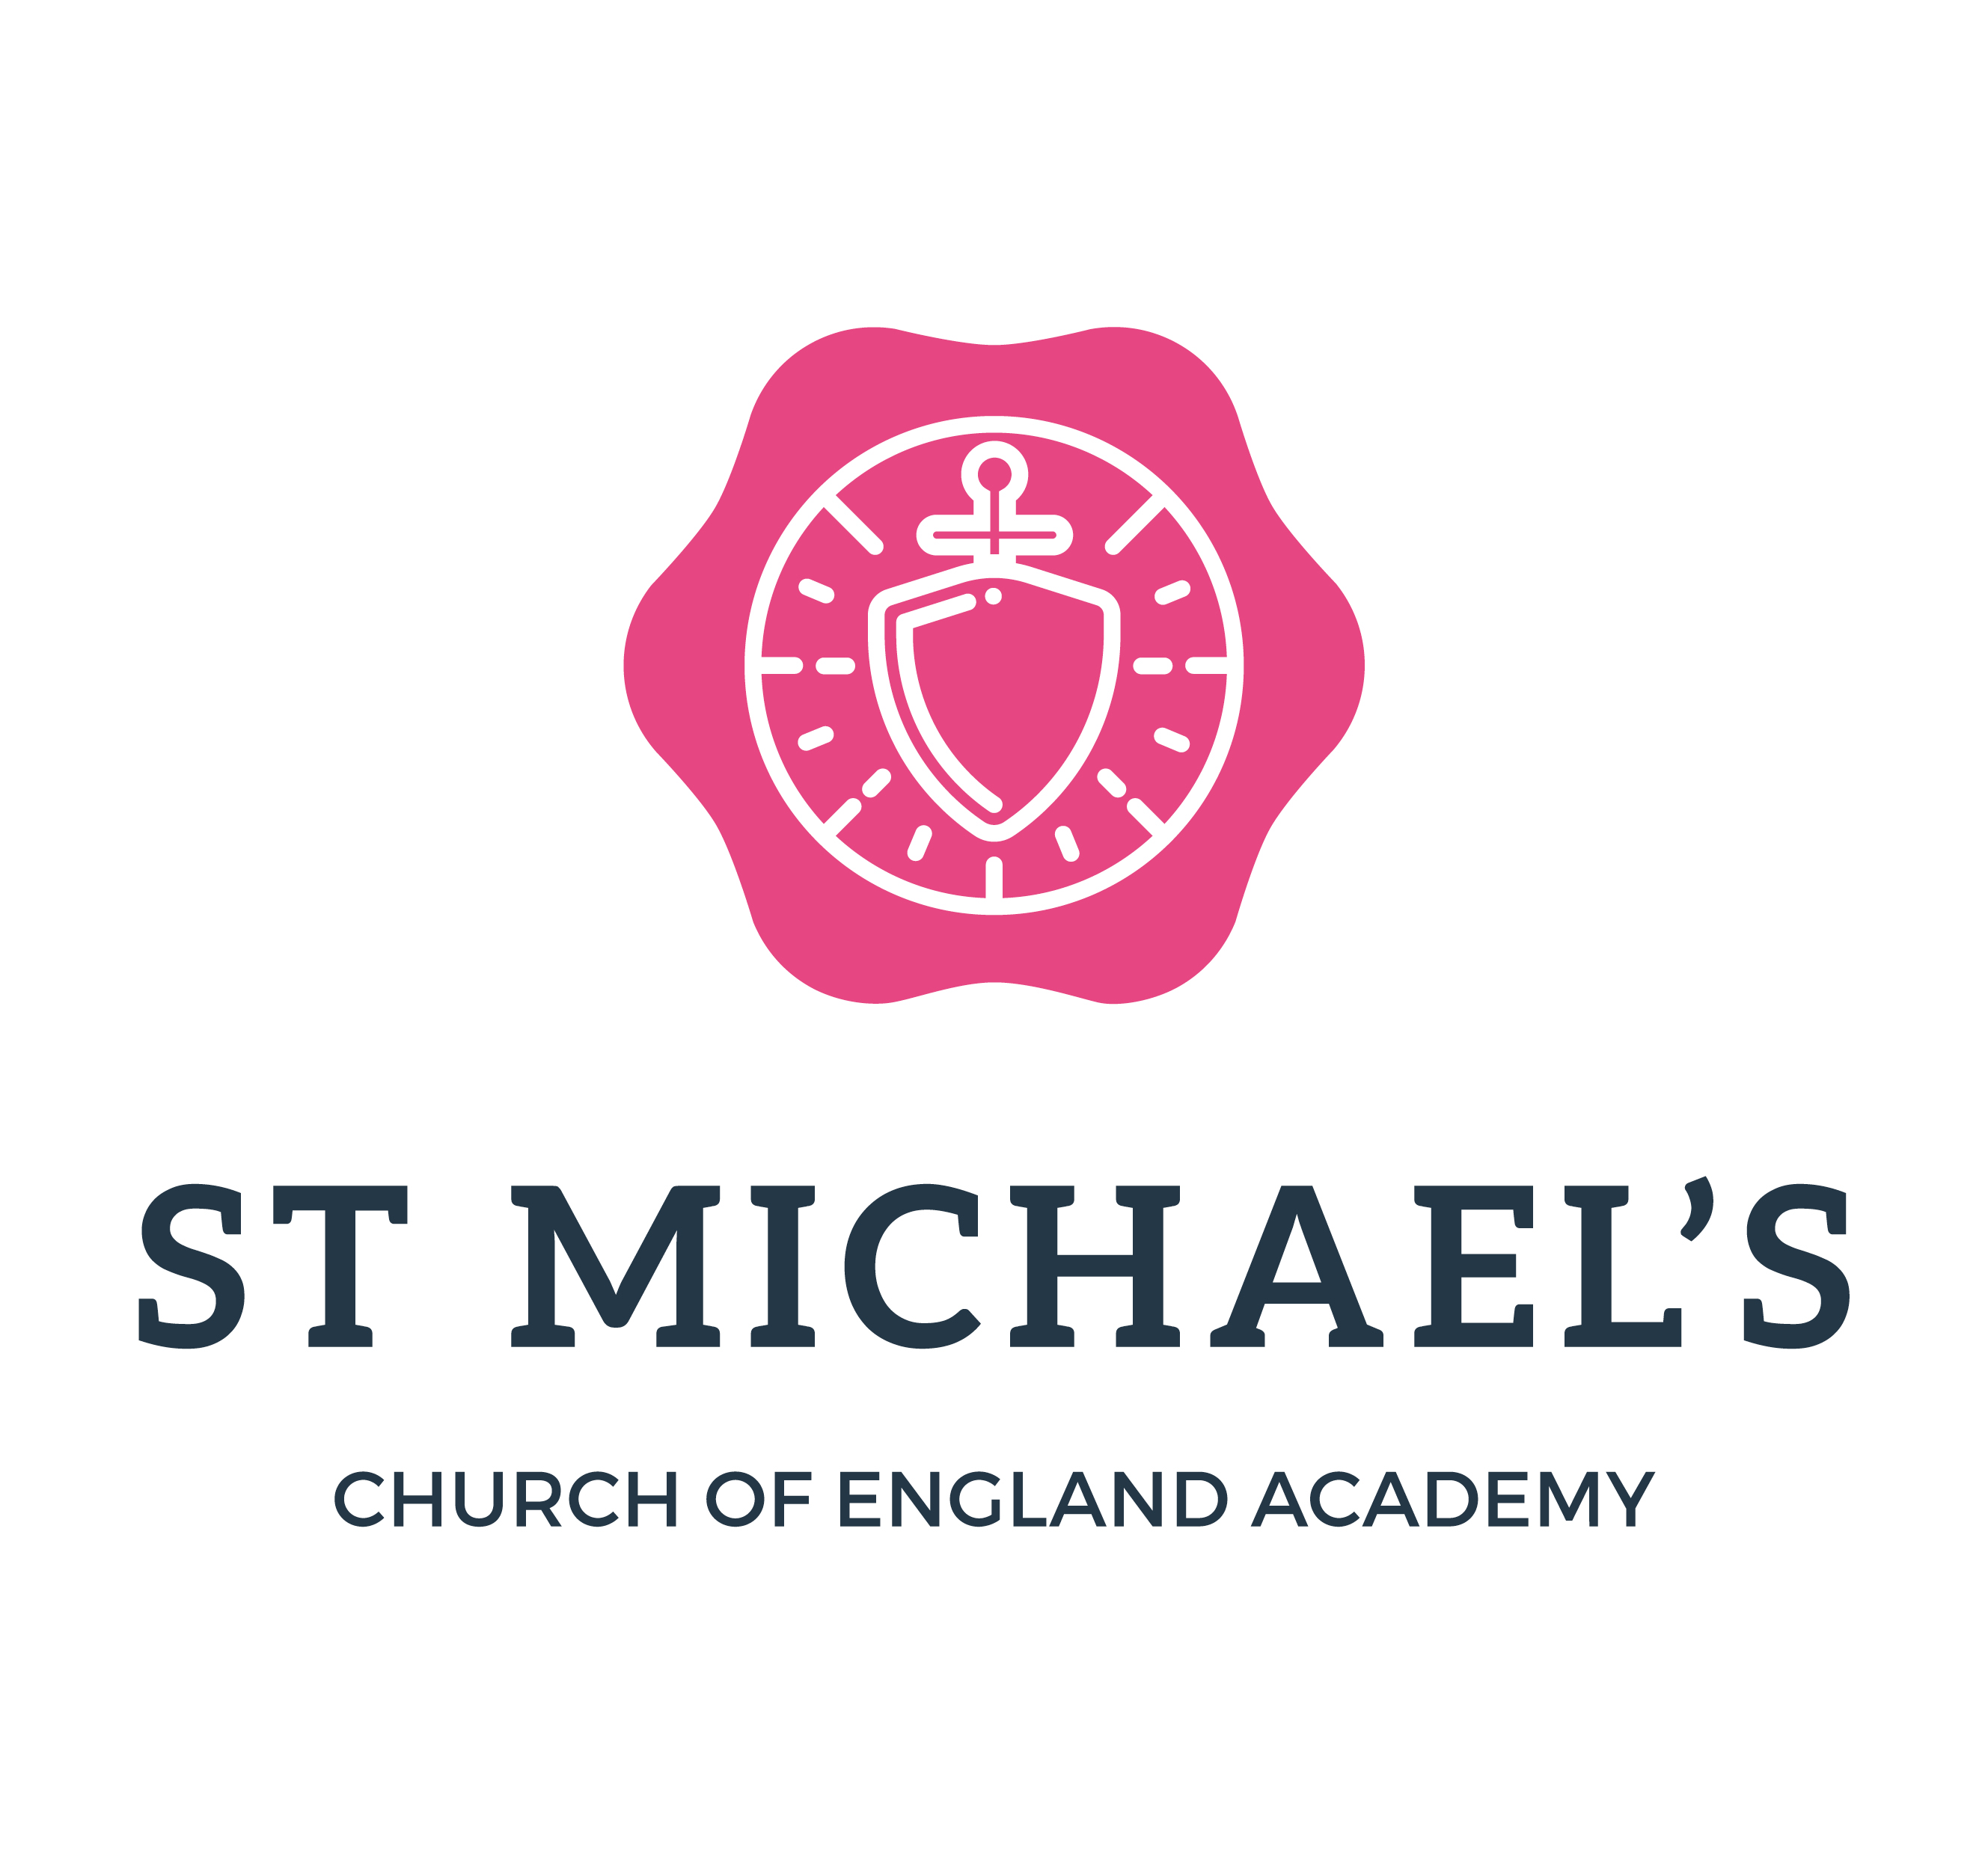
REQUEST FOR CHANGE OF SESSIONS

Name of Provider | St Michael’s C of E Academy
Name of Child |  | Date of Birth
Address |  | Postcode

Please complete the table below indicating the sessions requested:

Time  Day | 9 – 12 | 12 – 3 | To Start From ………………………………………………………………  Total hours requested  Total funded hours requested  Balance of hours to be charged  (see charging policy)
Monday

Tuesday

Wednesday

Thursday

Friday

Parent/Carer to complete one of the following statements:
Statement 1 (If your child is claiming a maximum of 15 hours per week, over a minimum 3 days, at the provider named above).

I confirm that my child will access h hours per week over days.
I confirm that my child does not access a free place with another Devon provider or with a provider in another Local Authority.

Statement 2 (If your child is claiming the free entitlement with more than one provider. The total claim must not exceed 15 hours per week and must be accessed over a minimum of 3 days).

I confirm that my child will access hours per week over days with this provider and:

He/She is also accessing hours per week over days with:
Name of Provider
Address of Provider

By signing below I confirm that the information I have provided above is accurate and true. I understand and agree to the conditions set out in this document and I agree to the provider claiming free entitlement funding as agreed on behalf of my child. I also agree that the information provided can be shared with the local authority and Department for Education. I understand that if I have given false information on this form I may be asked to reimburse the provider.

Parent/Carer/Guardian with legal responsibility
If entitled to 30 hours funding please complete the following information:
  11 digit ref number (DERN)
  Parent NI number(s)
If entitled to Tax-Free Childcare please complete the following: | Unique Reference number
Signed
Print name
Date

Please return the form as soon as possible and we will check availability.

I, being a parent/guardian/person with parental responsibility for the child named understand that the school
collects and uses certain types of personal information about pupils. The school is required by law to comply
with statutory obligations related to education and associated functions and may be shared with other
agencies for the prevention and detection of fraud and the protection of children. Personal information is
dealt with properly and securely and in line with the General Dara Protection Regulation (GDPR) and other
related legislation. For further information, please see the Privacy Notice which can
be found on our website..

